CPRS Tab by Tab: A Basic Orientation
https://vatraining.remote-learner.net/mod/page/view.php?id=31386
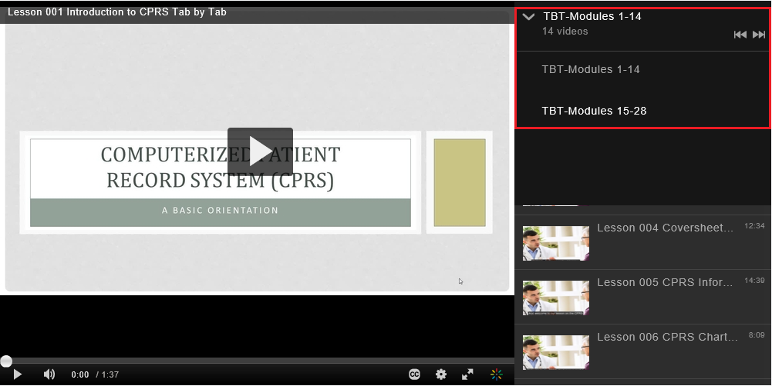

Lesson | Title | Time | Additional Resources
001 | Introduction to CPRS Tab by Tab | 1:27
002 | Setting up Access and Verify Codes See ADPAC for login  - Identify the four types of security codes used to access and work in CPRS.  - Locate the VistA application on your desktop.  - Observe how to create an electronic signature code. | 6:59  0:41  3:54  3:48
003 | Signing into CPRS  - Locate CPRS application on the desktop.  - Observe method to access CPRS using assigned access and verify codes.  - Observe the multiple ways you can select patients from within CPRS.  - Identify the purpose of a Patient Record Flag.  - Differentiate between Category 1 Patient Record flag and Category 2 flag. | 10:41  0:38  0:55  1:52  8:28  8:28 | See Lesson 25 for Custom Patient Lists
004 | Coversheet Tab  - Observe how to resize data sections on the coversheet.  - Observe the steps to enter a patient allergy.  - Observe how to display detailed patient information from the coversheet. | 12:34  2:15  4:23  3:26
005 | CPRS Informational Header  - Identify the purpose for each button on the CPRS Informational header bar.  - Identify the importance of selecting the appropriate Patient Location.  - Observe how to create a new outpatient appointment with CPRS. | 14:39  0:54  3:23  5:29
006 | CPRS Chart Menu and Selections  - Observe how to change patient records with CPRS.  - Describe the functionality of Clinical Context Object Workgroup (CCOW).  - Observe how to break and rejoin patient context link. | 8:09  0:48  1:38  2:40
007 | Problems Tab  - Identify the types of problem list views available within the Problems Tab.  - Observe how to appropriately enter a SNOMED code into the patient record with the Problems Tab.  - Observe how to annotate an existing problem. | 17:21  0:50  5:57  13:13 | See Lesson 16 for Encounter
008 | Meds Tab - Views  - Identify the four types of medication order that are viewed on the Meds Tab.  - Define the different medication order statuses.  - Describe the information found in the detailed view of each medication order type. | 10:42  0:25  5:13  7:23 | See Lesson 24 for Customization
009 | Meds Tab – Action  - Identify actions that can be taken on existing medication orders from the Meds Tab.  - Explain how to order new medications on the Meds Tab. | 12:00  0:23  7:03
010 | Orders Tab - Views  - Identify location of a current display view.  - Observe how to change display view.  - Observe how to create a customized view. | 9:18  3:10  3:48  6:45 | More information to follow on Auto DC/ Release event use for finding prior active orders on inpatient
011 | Orders Tab – Writing Orders  - Observe how to write orders from the order menus.  - Observe how to write a complex med order.  - Describe the functionality of an order set. | 12:13  2:39  4:46  7:38
012 | Orders Tab – Event Delayed Orders  - Describe when you would use the write delayed orders functionality  - Observe how to toggle between immediate release ordering and delayed release ordering.  - Identify risks associated with using delayed orders. | 12:44  1:08  10:27  10:48 | More information to follow on Away Sick in Hospital (ASIH)
013 | Orders Tab – Personal Quick Orders  - Observe how to set an order to send notification when resulted.  - Observe how to flag an order for clarification.  - Observe how to create a personal quick order. | 14:13  0:40  3:50  6:19
014 | Notes Tab  - Identify the meanings of the icons displayed on the Progress Note tab.  - Observe how to change display view.  - Observe how to create a custom view. | 9:54  6:56  1:20  4:07
015 | Notes Tab – Writing Notes  - Observe how to write a progress note.  - Observe how to access and use shared templates and patient data objects.  - Observe how to process a clinical reminder. | 17:50  1:20  5:26  12:45 | See CPRS Template Drawer SFVA Overview 2020 and CPRS Template-Copy Shared to Personal SFVA 2020 on SFVA CPRS site.
016 | Notes Tab – Encounter and Consult Resolution  - Observe how to complete an encounter form.  - How to complete a consultation request via the notes tab in CPRS. | 10:38  Skip*  6:23 | Skip to 6:23 for Consult Resolution
017 | Consults Tab  - Observe how to view and order consults.  - Identify the various actions that can be taken on a consult.  - Observe how to complete a consult with a progress note. | 17:59  1:05  5:54  14:39 | More information to follow on Community Care
018 | Surgery Tab  - Identify the meaning of the surgery icons.  - Identify the three type of reports that can be found on the Surgery Tab within CPRS. | 8:54  2:43  1:30
019 | Discharge Summary Tab  - Identify two additional fields to enter a discharge summary.  - Demonstrate how to link the discharge summary to the correct admission date. | 5:27  3:40  4:39
020 | Labs Tab  - Observe how to navigate the Labs Tab.  - Identify the benefits of utilizing the Cumulative View for displaying lab result information.  - Observe how to create a lab worksheet. | 13:13  0:30  2:50  5:22
021 | Reports Tab  - The different types of information that can be found on the Reports Tab.  - How to adjust the date range and max number of report settings for individual reports.  - How to retrieve remote data using the Reports and Labs Tab in CPRS. | 15:12  0:30  5:00  11:10
022 | Using Joint Legacy Viewer (JLV)  - Access and Log into JLV.  - Customize and configure JLV for your use.  - Display various types of health record data that can be retrieved from JLV.  - Locate additional training materials for JLV. | 10:43  0:30  3:20  1:50  1:38 | We recommend using JLV training site.
023 | Processing CPRS Notifications  - Differentiate between Information and Action notifications.  - Observe how to sort notifications within CPRS.  - Observe how to renew notifications. | 9:02  2:55  1:33  5:38
024 | Customizing CPRS Part I  - Observe how to change Coversheet parameters.  - Observe how to set a surrogate.  - Observe how to customize the order checks you receive. | 9:06  0:30  5:35  8:23
025 | Customizing CPRS Part II  - Observe how to create a Combination List.  - Observe how to create a Personal List.  - Observe how to create a list of default Progress Notes. | 16:05  0:30  5:28  10:16
026 | iMedConsent  - Identify the types of documents contained within the iMedConsent document library.  - Observe how to complete a consent form using iMedConsent. | 10:34  1:28  4:15
027 | VistA Imaging Display  - Identify the types of documents that can be found within VistA Imaging Display.  - Observe how to view digital images.  - Observe how to customize your display in VistA Imaging Display. | 10:57  0:32  5:35  9:40
028 | VistA Web VistA Web is decommissioned and replaced by JLV | Skip | We recommend using JLV training site.
20200617mgo

